Three Fables from Aesop

Fables are stories from around the world meant to teach morals to children. Every culture has them. Some of the most famous came from a slave from ancient Greece named Aesop.
Here are some of his stories...

The Dog and His Reflection
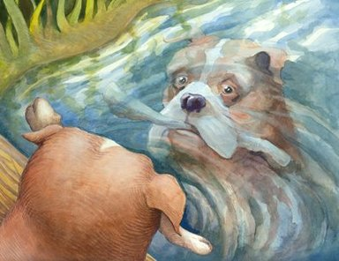
A dog was walking home with his dinner in his mouth. His dinner was a large meat bone. On his way home, he walked by a river. Looking in the river, he saw another dog with its own meat bone, that looked even bigger than his.
"I want that meat, too," thought the dog, and he opened his mouth to take other dog's dinner. When he did, he dropped his own meat bone into the river.

The Moral: Too much greed results in nothing.
Expression: "The grass is always greener on the other side."

Questions
- What adjectives would you use to describe the dog?
- What was the plot of the story?
- Character wanted (blank) but (problem), so (solution)

The Lion and the Mouse
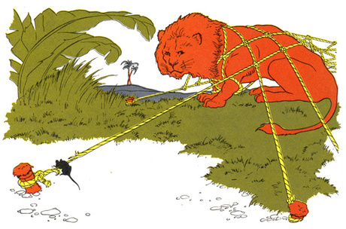
One day a lion woke up from his afternoon nap and saw a group of mice scurrying all around him.
His huge paw came down on one of the smallest mice with a loud SMACK!
The mouse said, "Please, mighty lion! If you let me go, I will owe you a great favor. Mercy please! Don't eat us!"
The lion took pity on the tiny mouse. Although he didn't see how a mouse could help him, the lion released the mouse and his family.
A few days later, the lion became trapped in a hunter's net. His roar made the whole forest tremble, but he couldn't get loose. The little mouse whose life was spared came upon the lion in the snare and used his sharp little teeth to gnaw the strong ropes until the lion was free.
The Moral: If you are good to others they might help you later.

Expression: "One good turn deserves another." Questions
- What adjectives would you use to describe the lion?
- What adjectives would you use to describe the mouse?
- What was the plot of the story?
- Character wanted (blank) but (problem), so (solution)

The Crow and the Fox
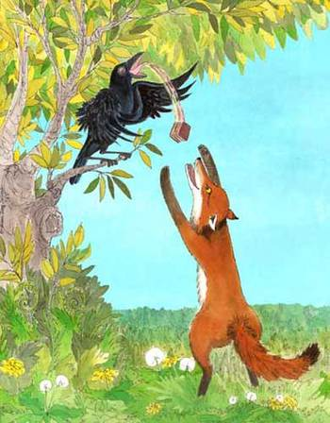
A fox was walking through the forest when he saw a crow sitting on a tree branch with a delicious piece of cheese in her beak. The fox wanted the cheese and decided he would outsmart the crow.
"What a noble and gracious bird I see in the tree!" proclaimed the fox, "What exquisite beauty! What fantastic glossy feathers you have! If your voice is as lovely as your beauty, you would have to be the jewel of all birds."
The crow was so flattered by all this talk that she opened her beak to sing a song for the fox and show off her voice.
"Caw! Caw!" she sang, and the cheese dropped to the ground for the fox to grab. He snapped up the delicious cheese and ran away laughing.
The Moral: Beware of flattery (阿谀, dulación, лесть)

Questions
- What adjectives would you use to describe the crow?
- What adjectives would you use to describe the fox?
- What was the plot of the story?
- Character wanted (blank) but (problem), so (solution)

After Reading the fable, rank the expressions below. 1-4 (one is most fitting) Discuss and explain your ranking.
- Flattery is like cologne (科隆, colonia, Кельн) to be smelt, not swallowed.
- A fool flatters himself, a wise (明智, sabio, мудрый) man flatters the fool.
- Flatterers look like friends, as wolves (狼) look like dogs.
- Easy come, easy go.

