What do I know about bats?

|  |  |  |  |
| --- | --- | --- | --- |
| **bats** | **prisoners of light** | **sleepers** | **Fluttering fruit** |

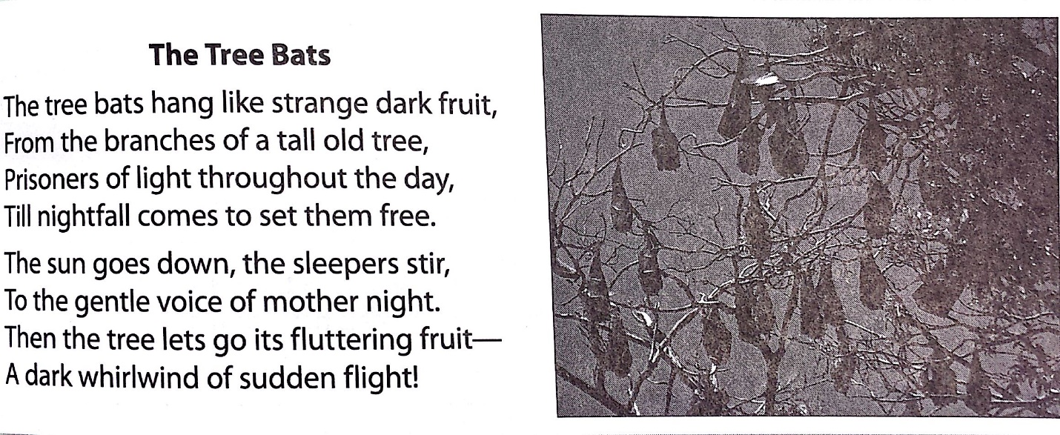

“throughout”: everywhere or all the time place or time

“stir” to move, wake up

“flutter”: flap, move quickly in the air

